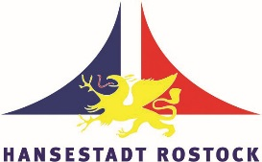
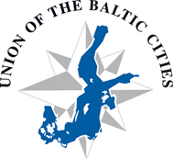

Press release, 11 March 2016

The Baltic Sea cities together in facing the refugees crisis

More than a million migrants and refugees crossed into Europe in 2015 causing a serious crisis and sparking off the debate on how to cope with the influx. The conference organized by the city of Rostock and the Union of the Baltic Cities on 14-16 March in Rostock, Germany, focuses on the Baltic cities role in dealing with resettling people.

Recent weeks are holding us under constant tension because the conflicts in Middle East and Africa have reached the Baltic Sea Region – Roland Methling, Mayor of Rostock, says. Hundreds of thousands persons from those regions are trying to get away from imminent danger and pain looking for shelter, a safe stay and opportunities in our cities.
This situation makes the cities face many highly exacting tasks. Housing, clothing, food, medical care, schooling, language teaching, employment for thousands of persons – all this has to be provided and mastered within a short time, in fact, instantly.
The prominent speakers, representing the European and regional organizations, e.g. the Committee of the Regions, the Council of the Baltic Sea States, the German Government and the Parliament, as well as the UBC cities, are to present their experiences and best practices and possible solutions on how to face this tremendous challenge.
Many cities already have experience in how to integrate people from different cultures. But there are also new requirements in the field of public order and security related to the threat from terrorism. The attitude of the host society and its involvement in the reception of refugees are of highest importance.
The outcome of the conference is planned to be reported to the corresponding levels of the European Union – Per Bødker Andersen, the President of UBC, concludes. The cites should make their voices heard because this is the level where the problems have to be tackled and solved.
At the XIII UBC General Conference, held in Gdynia in October 2015, the Resolution on the Refugees Situation in Europe was adopted.
More information:

http://www.ubc.net/news,2,3525.html
City of Rostock, Karin Wohlgemuth, karin.wohlgemuth@rostock.de, +49 381 3811452
Paweł Żaboklicki, Secretary General, pawel.zaboklicki@ubc.net, +48 602343332
UBC Secretariat, info@ubc.net, +48 58 3010917

