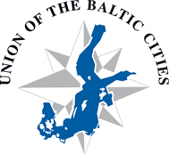

The programme of the Gender Working Group Meeting
Rostock, March 14, 2016, 5 p.m.

- Opening and welcoming
- Presentation of the Action Plan 2016 of the WG
- New ideas on the promotion of gender equality in the “matrix”
- Gender Equality seminar in autumn 2016
- Promotion of the Working Group and new members
- Open discussion

