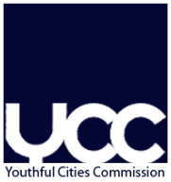 | Registration  for the UBC- Youthful Cities Commission´s open meeting in  Turku, Finland  April 12-15, 2016 | To be sent to  Lena.hernandez_modin@gavle.se  by  March 23, 2016

Please type in block letters. Each participant is asked to fill in a separate form.

^{First Name} | ^{Family Name}
Institution / Organisation /City Department

Please also fill in the following box
^{Street}

^{ZIP-Code} |  | ^{City}
^{Country}

^{Phone} |  | ^{Fax}
^{E-mail}

Details: (tick necessary choices)

I want to be accommodated in the suggested hotel

I am a vegetarian

Other special needs:

Arrival: (please make sure that you write your exact arrival time and place)

Date of arrival: 12th of April approximate arrival time:
(airport, ferry harbor, train station, bus terminal…)

Date of departure: 15th of April approximate departure time: at
(airport, ferry harbor, train station, bus terminal…)

The registration is binding

