CHARLOTTA.eps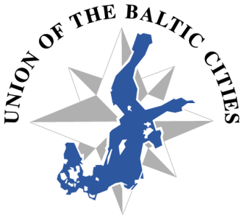

**73rd Meeting of the Executive Board**

**Dolina Charlotty, Poland, 10-14 June 2015**

# PRACTICAL INFORMATION as of 9 June 2015

**MEETING VENUE**

Dolina Charlotty

Strzelinko 14

76-200 Słupsk

Poland

**REGISTRATION & HOTEL BOOKING**

Registration online at <http://goo.gl/forms/yGwqSLmjZw>.

**Registration still possible provided the rooms are available.**

**ACCOMMODATION**

Member cities representatives will be accommodated at:

Dolina Charlotty

<http://www.dolinacharlotty.pl/en/accommodation-page-56457>

The special prices for the UBC member cities representatives are as follows:

Double room for single use, 250 PLN / night

Double room (one double bed), 300 PLN / night

Double room (two separate beds), 300 PLN / night

Apartment for 2 persons, 500 PLN / night

Extra discount 50% for the night on 14 June if someone wishes to stay till 15 June

1 EUR = 4,0161 PLN as of 24.04.2015

All meals during the stay are included for the UBC guests.

The participants will have free access to wellness zone - swimming pool, jacuzzi, saunas, sanarium, as well as to the fitness room, zoo, sealarium.

**AIRPORT TRANSFERS**

Free transfers will be provided from/to the airports in Gdańsk, Szczecin-Goleniów and Bydgoszcz. Look for the card with UBC & Dolina Charlotty logos at the arrivals.

**ACCOMPANYING EVENTS**

In connection with the Executive Board meeting the following accompanying events will be held at Dolina Charlotty:

- UBC BBQ Championship (<http://bbq.charlotta.pl/en/>)

- Young Rock Bands contest (<http://www.legendyrocka.com/en/about-the-competition-page-86044>)

Cities wishing to participate in accompanying events are requested to contact as soon as possible Ms Karolina Pędziwiatr, [k.pedziwiatr@charlotta.pl](mailto:k.pedziwiatr@charlotta.pl)

# CONTACT PERSON

With any practical question please contact:

Ms Karolina Pędziwiatr

Event Manager

Dolina Charlotty Resort & SPA

tel. +48 59 84 74 372

mobile: +48 667 710 638

e-mail: [k.pedziwiatr@charlotta.pl](mailto:k.pedziwiatr@charlotta.pl)

Ms Lidia Wiśniewska

Dolina Charlotty Resort & SPA

tel: +48 59 847 43 49

mobile: +48 667 711 570

e-mail: [l.wisniewska@charlotta.pl](mailto:l.wisniewska@charlotta.pl)