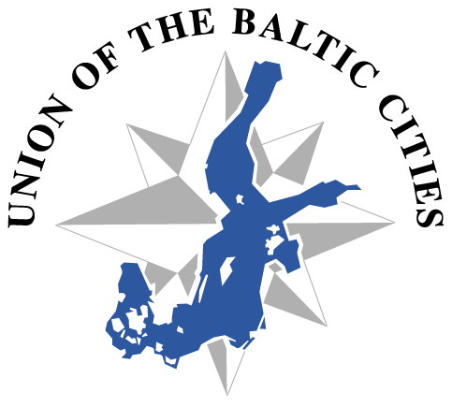

Agenda UBC Cultural Cities Commission
Riga 12.3.2015, 8:00 – 9:30
National Library of Latvia
Mūkusalas street 3, Riga, Latvia
www.lnb.lv/en/nll-new-building

N.B. The meeting is in connection with the Cultural and Creative Crossovers Conference with accreditation as was announsed in the inviation to this meeting.
If You have not the accreditation, you can join us by skype calling
Ilona Asares skype karkasonn.

AGENDA

- Opening of the meeting

- Election of the chairperson for period of 2015-2017 (until the UBC GM 2017)

- Election of the vice-chairperson / persons for period of 2015-2017

- Steering Group for period of 2015-2017
UBC follow-up seminar at Charlotta 10-12 June at UBC Board meeting (2-3 members present, Action Plan presentation
UBC General Conference, Gdynia 27-30 October, (2-3 members present, A presentation of the Cultural Cities Commission)

- Communications Officer for period of 2015-2017
-UBC Communications Seminar, Turku 15-16 April
-Follow-up seminar at Charlotta 10-12 June at UBC Board meeting
-Communications workshop at UBC GC, Gdynia 27-30 October

- The Action Plan 2015 and 2016 -17, discussion. N.B. DL 29.5.2015

- The Budget 2015, budget plan 2016 and 2017

- The VI Annual Forum of the EUSBSR, 'Achieving e-Quality by Connecting the Region', will be held on 15-16 June in Jūrmala, Latvia

- Other matters

Yours Jaana Simula, City of Pori, phone +358447011251
The following cities sent the names of representatives to the Cultural Cities Commission.
Bergen, Elbląg, Espoo, Chojnice, Gdańsk, Hiiu, Jēkabpils, Jurmala, Jyväskylä, Kaunas, Kemi, Kolding, Kotka, Kristianstad, Liepāja, Malmo, Narva, Naestved, Örebro, Palanga, Pori, Riga, Rostock, Siauliai, Tampere, Tartu, Tukums, Turku, Umea, Vaasa, Vilnius
The contact details are available on the city's pages at www.ubc.net
Also Gargzdai is interested in the Commission.

