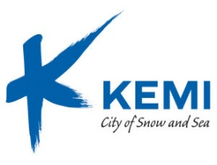

72ND Meeting of the Executive Board
Kemi, 25-27 February 2015

PROGRAMME

WEDNESDAY, 25 February 2015
Afternoon Arrival to Kemi
19.30 Dinner at Hotel Merihovi, Keskuspuistokatu 6-8, Kemi

THURSDAY, 26 February 2015
Kemi City Hall, Valtakatu 26, Kemi
9.00 Registration and coffee
9.30-12.00 Meeting of the Executive Board open session
10.40 Coffee & tea
12.00-12.20 Press conference
12.30-13.30 Lunch (Panorama Café, the top floor of the Kemi City Hall)
13.30-15.45 Continuation of the Board meeting closed session
14.30 Coffee & tea
16.00-17.00 Visit to museums of town history and regional art
18.00-22.00 Dinner at the Snowcastle (Snow Restaurant) and get-together at the Castle
Lounge (dress code: warm and casual), Kauppakatu 29, Kemi

FRIDAY, 27 February 2015
08.00 Snowmobile safari or
09.00 Visit to Outokumpu Chrome Mine
11.45 Lunch at Hotel Merihovi
Departure of participants

