Curriculum Vitae
Personal details
Name:  Date of birth:  Place of birth:  Address:  Phone:  Email: | Krzysztof Kożyczkowski  17.07.1987  Puck  City: Reda, 84-240  Street: Brzozowa 92  +358 414748421  krzkoz@utu.fi | 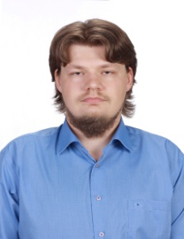
Education
2014 - onwards  2009-2011  2006-2009  XII 2008  2003-2006 | University of Turku in Finland,  MA Baltic Sea Region Studies,  Naval Academy in Gdynia,  Masters degree in International Relations,  Specialization: World regions,  Kashubian-Pomeranian Collage in Wejherowo,  Bachelors degree in sociology,  Specialization: Local administrations and social problems,  Training: „Acquiring of European founds for NGO”,  High School No.1 in Wejherowo.
Work experience
VII 2008  IV – IX 2012 | Internship in MOKSIR Reda Culture Center, assistant in organization of cultural events and children summer camp,  Internship in the Financial department of Wejherowo town hall, responsible for verification of taxpayer personal data, database updates and archiving of outdated documents.
Languages
Polish  English  German | - Native,  - Fluent,  - Beginner.
Skills and Qualities
- Good computer skills. Good command of Microsoft Office, able to quickly adapt to new programs,
- Effective communication and interpersonal abilities,
- Flexible and able to multitask.

Hobbies
- Sci-fi literature, history of Middle ages, German culture, new technologies, virtual communities, cooking.

