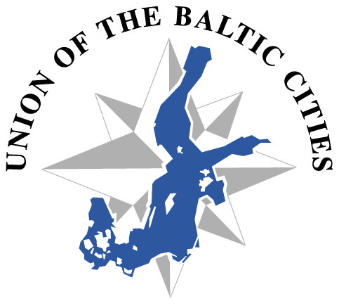
Commission on Culture

Invitation to the Annual board meeting of the Commission on Culture
Tallin 12.11.2014, 14:00- 16:30
National Library of Estonia
Tõnismägi 2, 15189 Tallinn, Estonia
http://www.nlib.ee/en

AGENDA

- Opening of the meeting
- Election of the chairman the board
- Election of the vice-chairman of the board
- The Action Plan 2014 up-to-date
- The Budget 2014 up-to-date
- Nomination of the CoC’s candidate for the Baltic Sea award 2015, see: http://www.ubc.net/news,2,3083.html
- Consolidation Work, see http://www.ubc.net/documentation,76,3036.html
- EUSBSR Priority Area Culture Conference ‘Learning from the past, looking into the future’ on 13-14 of November in Tallinn. See: http://www.eusbsrculture.eu/
Friday, 14 November – Looking into the future
Venue: National Library in Tallinn10.00-11:15, Session 3
2nd BSR Cultural Dialogue (focus on culture & social inclusion)-continuation of the cultural dialogue started during the EUSBSR Annual Forum in Turku.
The Vice Chair of CoC is taking part in the discussion, discussion with the board about the UBC cities ideas about culture and social inclusion.
- The Nordic Culture Days 2014, 24.-26.9.2014 in cities Pori and Rauma, Finland in co-operation with Mittnorden and provinces of Satakunta and Ostrobotnia. Results.
- Other matters

The Board meeting is open to UBC member cities representatives.
Others than board members are asked to confirm by e-mail jaana.simula@pori.fi on the 10th of November. Thank You!

I’m looking forward to see you very soon!

Jaana Simula
Vice Chair (acting)

