
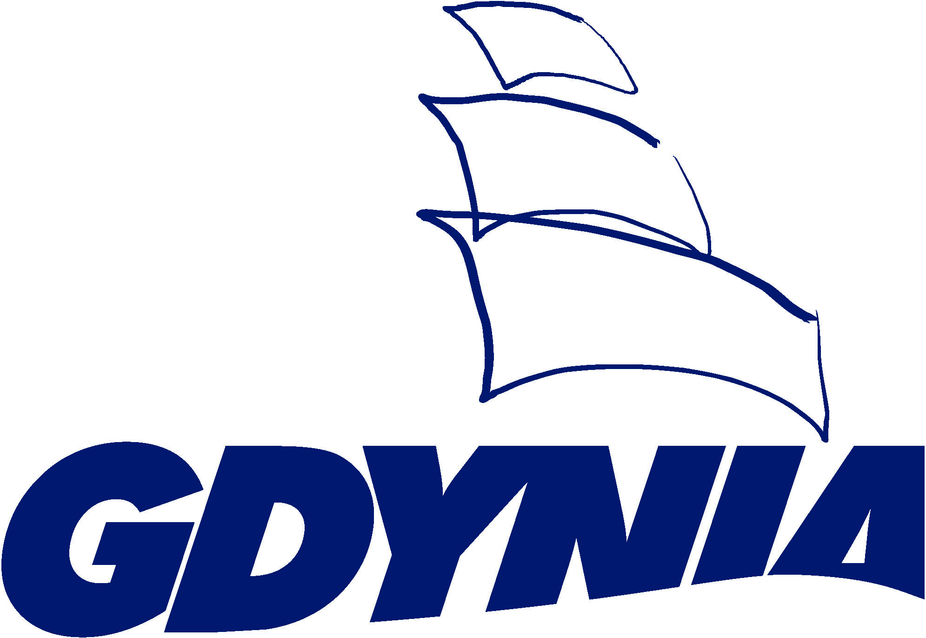
Baltic Sea Region advancing towards Sustainable Urban Mobility Planning
Gdynia, 23-24.10.2014

Registration Form

I. Personal Details

Name and surname:

Organisation:

Position:

City:

Address:

Phone: |  | Fax:
E-mail:

II. Accommodation Details

“Kuracyjny" Hotel - al. Zwycięstwa 255; 81 - 525 Gdynia
phone: +48 58 66 77 823; fax: +48 58 350 93 60
www.hotelkuracyjny.pl
The below rates are preferential ones and have been negotiated for the UBC Meeting. Therefore, the hotel should be reserved by the agency of UBC Commission on Transportation. The preferential prices are valid till 6th October when the reservation is made after this date cost of the hotel will be calculated according to the regular price.

Single room at 240 PLN/night (approx. 57 EUR/night)*
from: |  |  | to:
Double room at 299 PLN/night (approx. 72 EUR/night)*
from: |  |  | to:
* The price of the room will be calculated according to the euro exchange rate on the day of payment

III. Participation Details

1) I will participate in the lunch on 23rd October 2014 | Yes / No
2) I will participate in the dinner on 23rd October 2014 | Yes / No
3) I will participate in the workshop on methodology for self-assessment in SUMP process on 24th October 2014 (11:40 – 12:30) | Yes/No
4) I will participate in the workshop on micro SUMP - case study on Gdynia Główna hub area on 24th October 2014 (11:40 – 12:30) | Yes/No
5) ) I will participate in the CIVINET Inaguration Meeting on 24th October 2014 (11:40 – 12:30) | Yes/No
6) I will participate in the sightseeing on 24th October 2014 | Yes / No

If you have any particular dietary requirements, please note these:

........................................................................................................................................................

