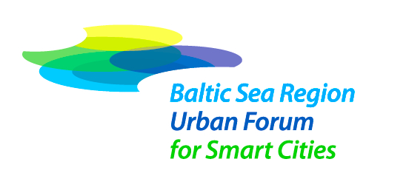

As the cities are playing a crucial role in the Baltic Sea Region development, UBC Board has, together with the Baltic Development Forum (BDF) and the City of Turku taken the initiative to prepare a concept for a “Baltic Sea Region Urban Forum for Smart Cities”.

For this, we have received approval and financial support by the Seed Money Facility of the European Union Strategy for the Baltic Sea Region.

Baltic Urban Forum concept was launched at the UBC General Conference in Mariehamn and ideas as well as initial concepts were discussed in the initiative group workshop on 19- 20 January 2014 in Tartu, Estonia.

Currently the initiative group is developing and focusing the concept of the Baltic Urban Forum.

The Baltic Urban Forum concept plan will be presented and further developed in Riga, Latvia on 23 April 2014, just before the Energy Cities Annual Conference (23-25 April 2014) in Riga. UBC Member Cities and representatives are invited to participate in both events.

As the Baltic Urban Forum will play key role in the Baltic Sea Region development in the next decade, we hope that your city, but also interested businesses or citizens organizations can use this excellent opportunity to provide your input to the concept.

The workshop will take place in the premises of the Riga City Council, Ratslaukums st. 1, on 23 April 2014 between 11-16.

Find more about the Baltic Urban Forum concept development:
http://smartcitylab.eu/buf/

Please notify the UBC Secretariat about your plans to participate in the Baltic Urban Forum meeting in Riga!

