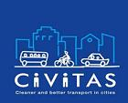
CIVITAS DYN@MO (DYNamic citizens @ctive for sustainable MObility) is
a European project, realised within CIVITAS Initiative, co-financed from 7th Framework Programme.
The project is aimed at implementation of innovative solutions within mobility, exchange of knowledge and experience among project’s partners within:
• the development of „web 2.0” systems and service,
• introduction of the citizen-friendly and city-friendly electric vehicles,
• engagement of citizens in planning process regarding mobility and enhancing the service quality.
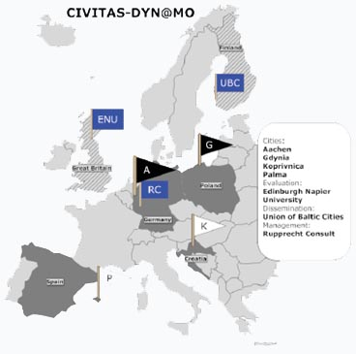
The project is realised by 4 dynamically developing European cities:
• Aachen (Germany),
• Gdynia (Poland),
• Koprivnica (Croatia),
• Palma de Mallorca (Spain).
Additionally, CIVITAS DYN@MO consortium consists of 24 local partners from the above mentioned cities. The project is also supported by Lund University (responsible for the project evaluation) as well as the Environment Comission of Union of the Baltic Cities (responsible for dissemination of the project ) and Rupprecht Consult (management of the project) .
Local consortium of the City of Gdynia is formed by Gdansk University of Technology (GUT), Gdansk University (UG) and PKT - local trolleybus operator.
Total cost of the project is 13,041,486.00 EUR of which 805,200 EUR is intended for implementation of Gdynia’s part of DYN@MO. Project started on 1st December 2012 and will run for 48 months.
Within CIVITAS DYN@MO six work packages were prepared:
- WP1 Sustainable Urban Mobility Plan
- WP2 Innovative, clean and energy efficient vehicles
- WP3 ICT and ITS
- WP4 Research and evaluation
- WP5 Dissemination and learning
- WP6 Project coordination and management
Work packages WP1-WP3 are called specialised and are being implemented by partner cities and their local partners (total of 24), while WP4-WP6 are being realised by all 27 project participants.
During the four years of the project, Gdynia will implement the following measures:
WP1 Sustainable Urban Mobility Plan
G1.1 Advancing towards a dynamic SUMP
On the basis of research, projects and consultations Gdynia will elaborate Sustainable Urban Mobility Plan, which will be approved by the City Council.
G1.2 Community project studies from SUMP
Within this measure Gdynia will prepare studies for priority actions indicated in SUMP, including PRT line, road traffic modifications, public transport lines distributions and promotion of walking, cycling and pedestrian areas. The prepared projects, analyses, simulations will be presented to citizens for discussion (i.e. via Gdynia’s Mobility 2.0 platform).
G1.3 Pedestrian areas and access management
Within the pilot project first city’s pedestrian area will be created. Additionally Gdynia will conduct promotional campaigns for cycling, pedestrian areas, urban electric transport, etc.
WP2 Innovative, clean and energy efficient vehicles
G2.1 Innovative Li-ion hybrid trolleybuses on new line
Two Gdynia’s trolleybuses will be equipped with alternative source of energy and will be coursing on new line including section without traction.
G2.2 Supercaps for more efficient trolley system
Within this measure Gdynia will install supercapacitor in trolleybus network, which will result in decrease of energy consumption.
WP3 ICT and ITS
G3.1 Transport model for Gdynia
3-level transport model for the City of Gdynia will be elaborated, which will be also used in elaboration of SUMP.
G3.2 Automatic incident detection system
The automatic incident detection system will be implemented on two most dangerous intersections (pilot project).
G3.3 Weight-in-motion and enforcement
The system will be introduced at two entry points of the city.
G3.4 Mobility 2.0 communication
Gdynia will create Mobility 2.0 internet platform called “Mobilna Gdynia”, which will enable to involve citizens in transport planning process. The platform will be also used for presentation of measures which are being implemented within DYN@MO project.
G3.5 Dedicated bus lanes/ HOV lanes control with the use of ITS
Within this measure the dedicated bus/HOV lane will be introduced together with system enabling identification of unauthorised vehicles driving the lane.

Within CIVITAS DYN@MO project the Baltic Sea Region Competence Centre will be created in cooperation of UBC, University of Gdansk and City of Gdynia. The Competence Centre will concentrate on training activities in the Baltic Sea Region.

