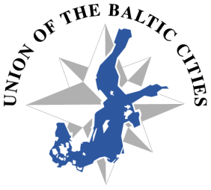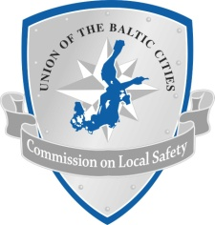

AGENDA OF THE 7th COMMISSION on LOCAL SAFETY MEETING
( 16 – 18 of October 2013 in Karlstad, Sweden)

Wednesday, 16.10.2013

Till 18.00 Arrival of participants, check in at hotel Scandic Winn
19.00 – 21.00 Get together dinner at Scandic Winn

Thursday, 17.10.2013
09.00 – 09.10 Registration
09.10 – 09.20 Welcome speech by representative of Karlstad Municipality
09.20 – 09.40 Opening of meeting by Chairman of the Commission
09.40 – 10.00 Report from XII UBC General Conference in Marienhamn - Secretary
SAFETY & SECURITY MANAGEMENT
Presentation of safety and security system in the cities. ( main institution responsible for safety & security, integrated security systems, crisis management)
10.15 – 10.35 Karlstad
10.35 – 10.55 Riga
10.55 – 11.15Gdansk
11.15 – 11.45 Coffee break
11.45 – 12.05 Vilnius
12.05 – 12.25 Tallinn
12.25 – 12.45 Turku
12.45 – 13.15 Discussion
COMMISSION’S ACTIVITY IN THE EU SBSR PRIORITY AREA - SECURE
13.15 – 14.00 Update on CBSS application for project finances – M. Fedoruk
14.00 – 15.00 Lunch at Scandic Winn

NEIGHBORHOOD WATCH PROGRAMME
15.00 – 15.20 Introduction of the program implemented in Sweden – Nacka representative
15.20 – 15.40 Introduction of the program implemented in Estonia – Tallinn representative
15.40 – 16.00 Discussion
16.00 – 16.30 Next year action plan and places of Commission’s meetings - secretary
16.30 – 16.45 Closing of the first day of meeting - Chairman
19.00 – 22.00 Dinner at restaurant Scandic Winn

Friday, 18.10.2013
09.00 – 10.00 Study tour to Karlstad Municipality
10.00 – 10.30 Coffee break
10.30 – 12.00 Historical tour in Karlstad
12.00 – 13.00 Lunch
From 13.00 Departure

