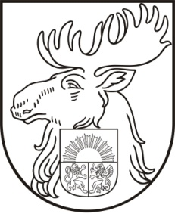
PRACTICAL INFORMATION
UBC COMMISSION ON LOCAL SAFETY

12 – 14 June 2013 in Jelgava, Latvia

Date: June 12th–14th 2013. Participants are expected to arrive on June 12th in the afternoon and leave on June 14th.

Accommodation: We kindly ask you to book your hotel room by yourself.

Recommended hotel:
Hotel Jelgava (Liela iela 6, Jelgava, Latvia- 40km from Riga)

Please send your reservation to www.hoteljelgava.lv / reservation code „UBC“
or phone your reservation to hotel front desk :
Ph.: +371 6 3026193, +371 6 30 23349
Mob.ph.: +371 29145961 / reservation code „UBC“

Price: 41,40 EUR/ double room + 6 EUR for breakfast (if there are living one person) per night including VAT.

20,70 EUR/ double room + 6 EUR for breakfast (if there are living two persons) per night including VAT.

Hotel has parking lot with video surveillance.

More information:
http://www.hoteljelgava.lv

Hotel reservation must be made before May 17th, otherwise we cannot guarantee availability of the rooms. When making reservation, please mention the reservation code: UBC.

The participants are welcomed to make hotel reservations in other hotels, as well. In this case please indicate the name of the hotel in the registration form.

Registration to the meeting: All registration must be made on the form provided with this invitation and sent by e-mail to aiva.saulite@policija.jelgava.lv

Transportation from/to the Airport/Seaport/ Rail station will be provided.
If you are coming by your own transport, we have added maps how you can find Hotel Jelgava.

Contact Person:
Dzintars Skuja,
Deputy chief of the Jelgava city Municipal Police
Dzintars.Skuja@policija.jelgava.lv,
Mob.ph. +371 29543538; +371 26018759
Ph. +371 63048943

