Newsletter October 2012 from the Committee of Culture

Cultural cooperation across border
Call for proposals for cultural cooperation The UBC Committee of Culture calls for proposals for cultural projects organized together with one or more UBC cities.
The only criteria is that it is a genuine cooperation between to UBC cities.
The committee has a small fund for this purpose, namely 3000€ in total Please note the deadline of 18th October.

Conference on Culture and Social inclusion 10-11 December 2012
The 10th and 11th of December the annual meeting of the UBC Committee of Culture will take place in Latvia. The topic will be Culture and Social inclusion. How can culture play an active role in social inclusion? You are all invited to contribute with an interesting best practice case to be presented at the conference. We would like also to present evident based research on the subject.
Please submit your proposal to Charlotte Lundqvist. The best practice cases that are selected to be presented will have their travel expenses and stay in Latvia reimbursed.
A small fund is available to meet travel expenses, if you cannot pay and if you are an UBC member. We would like to invite non UBC members. Their fee for the conference will be 200€ . A program will be sent out in the near future. Please reserve the dates already now!

WE NEED BOARDMEMBERS
The board consists of
Lone Leth Larsen, Kolding
Jaana Simula, Pori
Agrita Ozola, Latvia
Aleksandra Szymanska, Gdansk,
Charlotte Lundstrom, Umeå
Ninni Berggren-Magnusson, Gävle
Thomas Werner, Rostock.
And Olga Chersakova, Petersburg

We do not have members from Lithuania, Estonia and Norway, and we ask of you to put foreward your candidature.

Library exchange program.
Our Library exchange program has been successfully implemented.
Kolding- Linköping is starting in week 48, Gdansk Library is looking for a partner, and Jekapils in Latvia is also looking for a library partner.
Just to repeat the conditions: we would like to promote exchange of knowledge, and encourage you to match a librarian with one from another UBC country, to visit this person, and to be revisited in your own town by the person. We have allocated 1000€ per exchange, which means 500€ per participating library. Please contact Lone Leth Larsen (lola@kolding.dk) for more information.

Culture and Urban-planning conference next October.
Please note that next October the Urban planning Committee and the Committee of Culture will run a conference in Kolding on the topic of how culture and urban planning can be a driving force in the transition of the industrial past to the knowledge based future.

THE UBC cultural Prize.
At the conference in Latvia we will present the winner of the Cultural Prize 2012.
You are invited to propose candidates before October 18th.
Please note that the criteria for obtaining the prize is:
    - Demonstration of cooperation between two UBC cities.
    - An innovative promotion for promoting culture in you city
    - the process of cooperation is important
    - we want to emphasize sustainability
    - we want to encourage pilot projects
    - we want to encourage creativity: The good idea prize
The prize is 1.500€ and travelexpenses and accommodation covered
please post your candidate to Lola@kolding.dk

Culture as a driving force in social inclusion
Reflections from at visit to Gdansk.
Last week I had the great pleasure of visiting Gdansk because of the UBC network. First of all I can only promote visiting each other to get knowledge about how other cities work. And I am sure, I god great inspiration from what I saw!

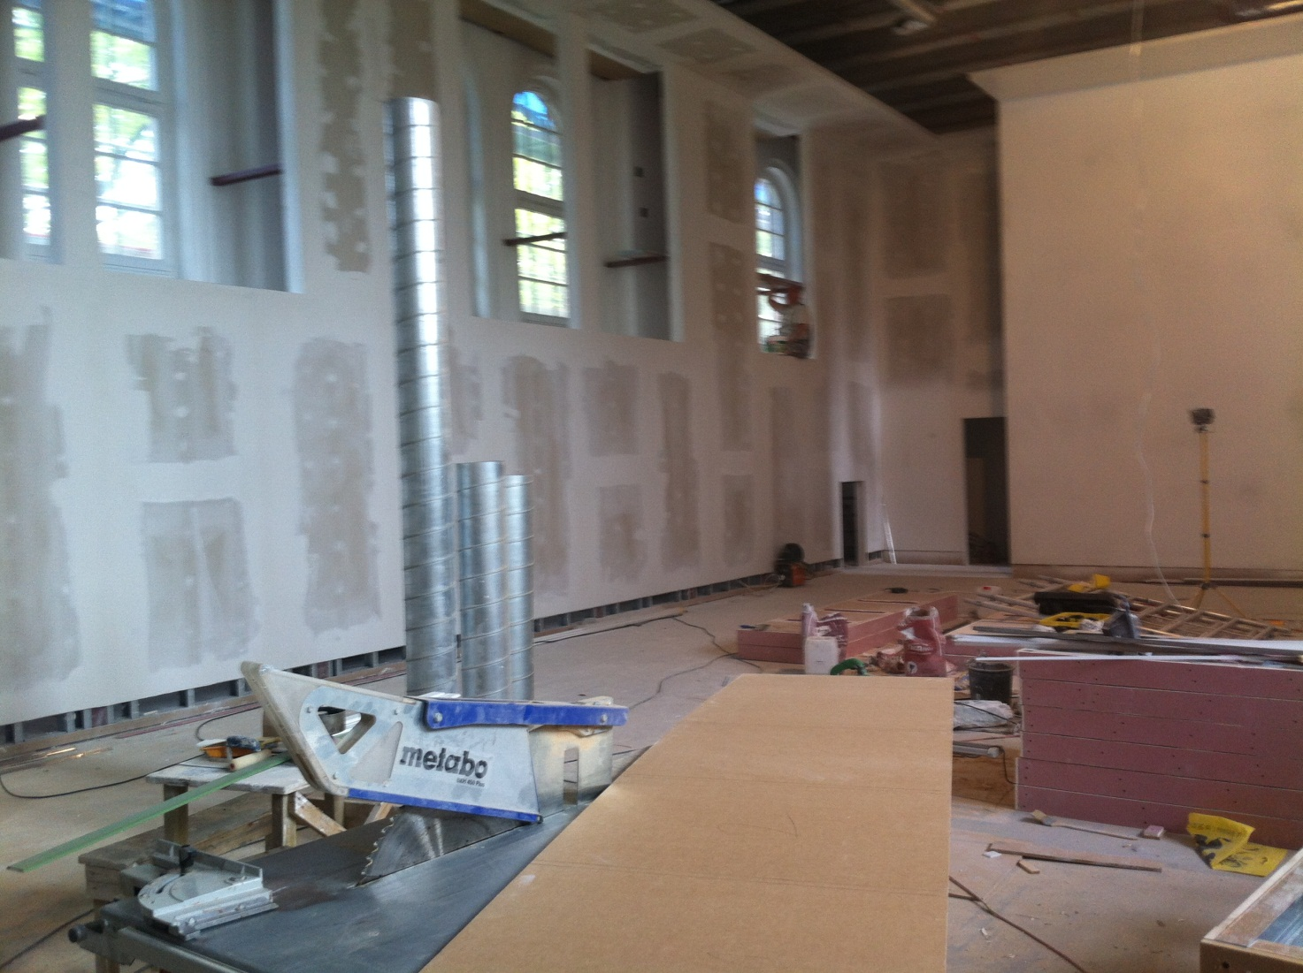
(the to be exhibition hall, where all walls and furniture will be made of gipsonite)
A Cultural Center is being established in an old school in one of the suburbs of Gdansk.
the area is a part of the town with many social problems and with not the best quality of life.
the Cultural center is being established trying to meet the needs of the surrounding society: a library, a IT center and a meeting place to meet both people from the surroundings as the artists in residence, that may stay in the center for a shorter or longer period.
The idea of the Center is to use culture as a driving force for enhancing the social inclusion in a deprived area, to meet the needs of the local inhabitants and at the same time establish an art-center, which will have possibilities for residence programs for different kind of arts, and possibilities for exhibitions of fine arts.
The Idea is great, and I am looking forward to see how the enthusiastic crew will succeed with a very tight budget, and to see if the participation of the local people has been well implemented.
The Library in the shopping mall
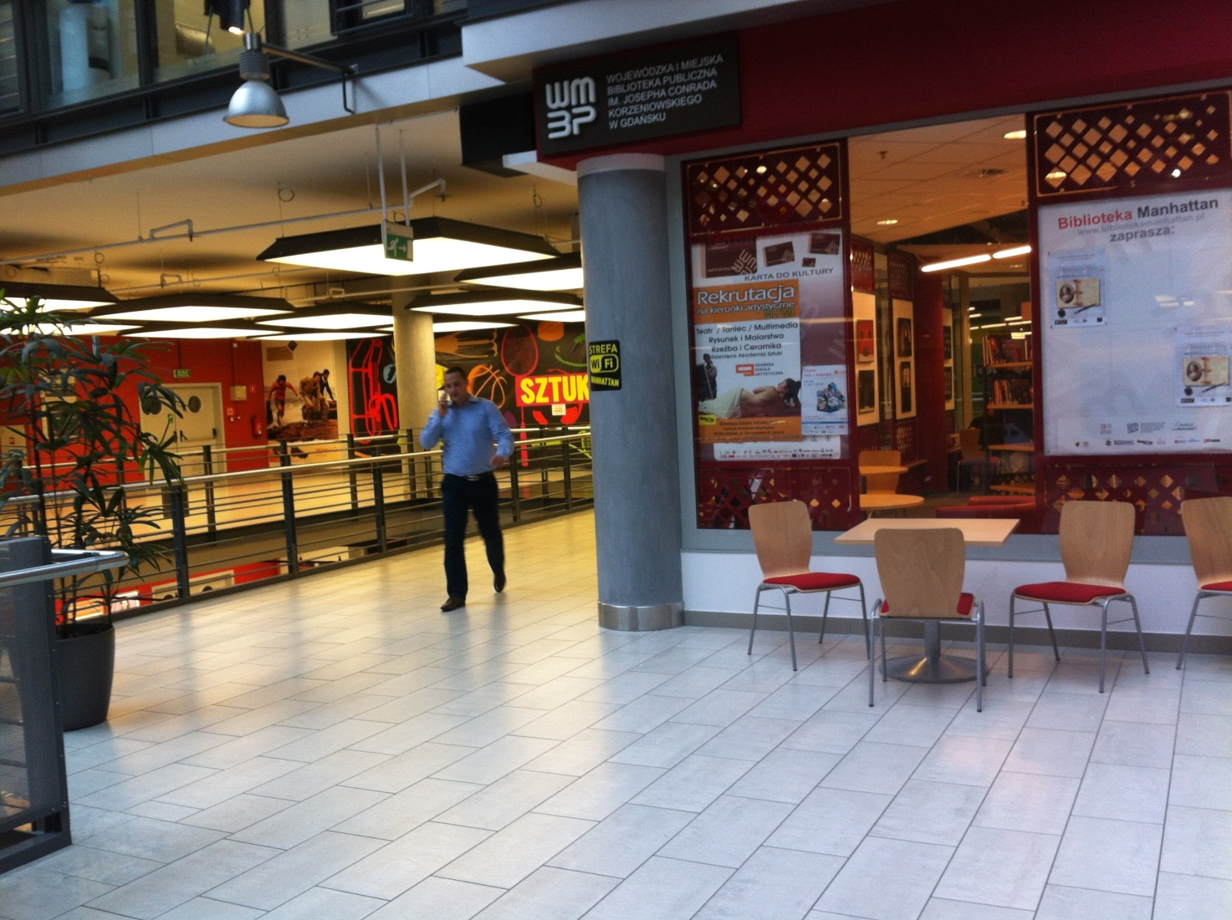
The other amazing thing I saw, was a new branch of the Gdansk Library. Situated in a shopping mall, the success of the Library has been immediate! In the first half year more than 17000 people has visited the library, that has a silent center, a reading area in nice lounge furniture, traditional library work and cultural events for adults and children.
Pawel Braun, the director of the Library of Gdansk tells, that the library that is promoting the reading of books, has actually reached a whole new audience, and that this poses a challenge in how to deal with this new target-group for traditional librarians.
Pawel Braun is for the moment rethinking the whole Gdansk library to be a place where people love to meet, spend hours with a book in a comfortable chair, and he has introduced areas with cosy noise, books without cover and many other interesting different thing for libraries .
The monumental Art Gallery
The last thing I saw was very monumental! In a Blocksky area Zaspa, the very area where Lech Walesa lived in the 1980’es a movement started in the late 90’es with inviting renown artist from Poland and abroad to decorate the very tall endfacades of the blocks.
It has turned out to become a mural painting festival taking place every year, where 5 new murals are made every year. The success of the project is that quite a boring Blocksky area has turned into something unique, it has stimulated the association of the houses to actually paint the houses, and has stimulated an agitated debate in the area where some 20 000 people live on the use of arts. Many of the inhabitants are very proud of their art, while others are against using the houses as galleries.
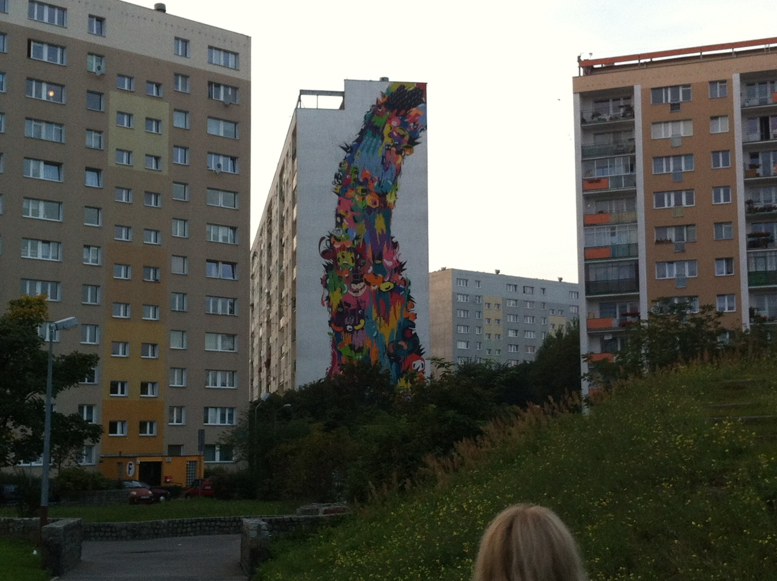

All the examples, I have shown you are examples of how culture can be an important factor in developing people or social deprived areas, in how culture has the potential of influencing the daily life of many people, and give them new hopes, aspirations or directions. Very important I think for the theme of the December conference in Latvia, where we will discuss in more detail and with more examples and best cases about Culture and social inclusion.

--

