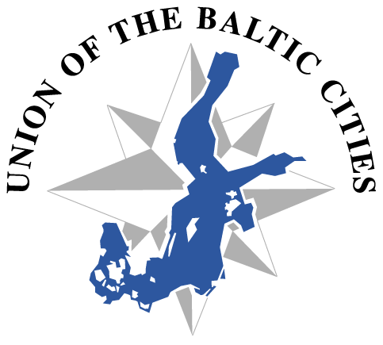

21.5.2012

To:

UBC member cities

UBC commissions

Invitation to Project Preparation meeting!

Expert exchange has been identified as a very important strategic issue between UBC cities and commissions. Cities of Jyväskylä and Turku from Finland have jointly decided to prepare a project proposal, and invite now other interested cities and commissions to take part! The aim of the project is to support UBC Strategy implementation by various events and expert exchange.

The Citizenship 2007-2013 programme offers funding for projects implementing town twinning. The deadline for applications is 1th of September 2012 and due to this the project preparation timetable is extremely tight. City of Turku and its think-tank on Baltic Sea Region issues - Centrum Balticum Foundation - are ready to act as a project coordinator.

The project funding offers support for organizing events. It means that every city that is organizing an event during project time, will receive support of (on average) 40€/participant/day. It has been planned that for example two Urban Forums, various workshops and Communication training etc. could be organized with the support of this project during years 2013-2014.

Do you want to contribute by organizing an UBC event in your city during years 2013-2014? Take part on

Project Preparation meeting in Turku, Finland on 7th of June 2012 between 09-15 h.

Please register to the project meeting by 30th of April to helina.yli-knuutila@centrumbalticum.org. You will have also the possibility to attend to the fifth annual National Baltic Forum held in Turku at the same time (on 7.-8. June). More information here: www.centrumbalticum.org/tapahtumat

If you’re not able to participate to the meeting, but are willing to participate in the project, please send your ideas and comments by e-mail before 7.6.2012

(helina.yli-knuutila@centrumbalticum.org)

Welcome to make practical cooperation!

Marketta Mäkinen

Director of International Affairs

City of Jyväskylä

Mikko Lohikoski

UBC Strategy Coordinator

City of Turku

Attachment 1

Draft of Project proposal: Town twinning to implement EU Strategy for Baltic Sea Region

Project proposal in practice, for example:
- Strengthening links between UBC Cities and UBC Commissions to foster the implementation of the Baltic Sea Strategy
- Urban Forums for political decision makers
- Workshops to implement UBC Communication and Marketing Strategy
- Seminars/forums to change experiences and knowledge about relevant themes for experts
- Events to support/accompany UBC General Conference

Project partners:
- City of Jyväskylä
- City of Turku (Centrum Balticum foundation /UBC Strategy coordinator)
- UBC Secretariat (tbc)
- Member cities of UBC (at least from 3 different countries than Finland)

Suggestion for timetable for preparing the project proposal:

18.5.2012 Invitation to participate to the project
7.6.2012 Meeting of the interested partners: Planning the project content, timeframe and partners’ roles

8.6.-13.7. Writing the application and collecting necessary attachments from the partners

14.7.-30.7. Summer holidays

15.8. (online) Meeting of the project participants: Checking the application, activities, timetable and budgets

16.8.-30.8. Application finalized and sent to the Citizenship -programme

Main question in this stage:
- Identify interested project cities
- Identify areas, where cities would like to do more practical cooperation under Baltic Sea Region Strategy for example:
  - Environmental sustainability
  - Research and innovations, enterprises etc.
  - Energy markets, transportation
  - Education, youth, culture, health
- Identify concrete project activities: events

Please register to the meeting and we will send you some more ideas to consider before the meeting. If you have any questions on funding or comments beforehand, please contact Ms. Yli-Knuutila (helina.yli-knuutila@centrumbalticum.org).
Attachment 2

C.5 Draft budget (for example)

Expenditure | Note! | Total budget €  (for example)
1. Staff: administration and coordination of the action | max 500€/year/partner  (for example 6 partners, two years) | 6 000€
4. Production, communication and dissemination costs | max 1500€ for websites  max 1500€ for publications | 3 000€
5. Training and event (conferences, seminars and meetings) costs directly linked to project activities | average 40 €/participant/day is paid to the host of the event  (for example:  - two Urban Forums with 100 participants for two days  - two study visits for experts with 15 participants for three days  - two workshops for Communication training with 20 participants for two days | 8 000€/Urban Forum  1 800€/study visit  1 600€/work shop  22 800€
Total expenditure: |  | 31 800€

Project grant can’t exceed 80% of total eligible costs.

