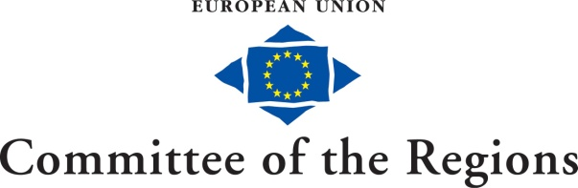

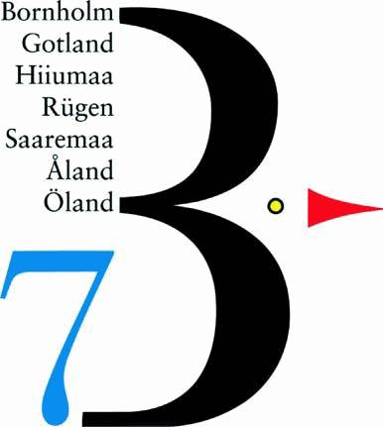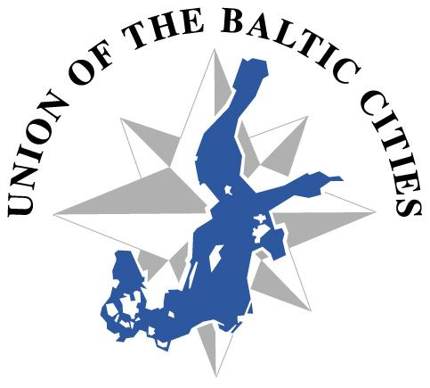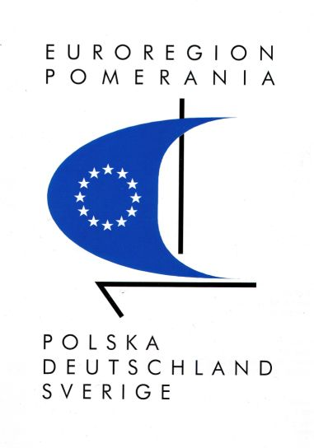

Declaration of common interest 2012 - 2015

The Secretary General of the Committee of the Regions (CoR), Mr Gerhard STAHL

and

the Chairman of the Baltic Sea States Subregional Co-operation (BSSSC), Mr Olgierd Geblewicz,
Chair of B7 Board (B7), Mr Ulla Pettersson,
President of Union of the Baltic Cities (UBC), Mr Per Bødker Andersen
President of Euroregion Baltic (ERB), Mr Roland Gustbée
Secretary General of Euroregion Pomerania (ERP), Mr Paweł Bartnik

declare their common interest in continuing the cooperation – previously realised by BSSSC members as members of the CoR and enhanced by the Declaration of Common interest between CoR and BSSSC signed in February 2007, and Declaration of Common Interest between CoR and BSSSC, UBC and B7 signed in December 2008.

By signing the following Declaration for the years 2012-2015 the cooperation is enlarged to include all BSR organizations, mentioned at the end of this declaration, representing local and regional level of governance in the Baltic Sea Region.

The signing associations will coordinate in between themselves and will assign one single representative for their contacts with the Committee of the Regions.

In general, BSSSC, B7, UBC, ERB, ERP participation in the work of the CoR should be further fostered wherever this provides a political added value for all parties. Efforts to further develop the cooperation will be made in particular in the following fields:

1. Involvement of expertise in selected areas of interest of the Committee of the Regions.

Drawing on the expertise of its members and working groups, representatives of BSSSC, B7, UBC, ERB, ERP may be invited on a case-by-case basis to contribute actively to the work carried out by the CoR Secretariat on specific topics. This may include, if appropriate, support to the CoR Commission’s secretariats in their assistance to rapporteurs, including the monitoring of the implementation of the subsidiarity and multilevel governance principles in specific dossiers.

2. Dialogue between the European Commission and the Associations of Regional and Local Authorities.

The CoR Secretariat will include BSSSC, B7, UBC, ERB, ERP among the associations invited to the dialogue between the European Commission and the Associations of Regional and Local Authorities as established by the EC’s Communication (COM (2003) 811 final). Moreover, the BSSSC, B7, UBC, ERB, ERP will be given the possibility to respond to calls for meetings (as published on the CoR website). They may also ask CoR Secretariat for help with arrangement of meetings with EC representatives in case of discussion need concerning new EU legal acts or those under preparation.

3. Participation in conferences and other activities organised respectively.
The CoR Secretariat and the Secretariats of BSSSC, B7, UBC, ERB, ERP will explore how to further improve the coordination of their communication channels to increase the visibility and impact of their joint actions. Specifically, the CoR Secretariat and the Secretariats of BSSSC, B7, UBC, ERB, ERP should aim to maximise possibilities for mutual participation in events organised by each party. More specific actions could include:
- Where appropriate, the participation of speakers from BSSSC, B7, UBC, ERB, ERP at events organised by the CoR and vice versa.
- CoR and BSSSC, B7, UBC, ERB, ERP agree to explore the possibilities to co-organise seminars in the Baltic Sea Region in 2012-2015, on the themes of mutual interest, i.e. EU maritime policy, the development of the Trans-European Networks in Northern Europe sustainable energy and adaptation to climate change, Multiannual Financial Framework, Europe 2020 Strategy, culture, common market and multilevel governance, demographic change, EUSBSR, by drawing on the expertise and experience of the local and regional level in the Baltic Sea Region.

4. Joint activities in the field of communication and the mutual publicity of key events.
The CoR Secretariat and the Secretariats of BSSSC, B7, UBC, ERB, ERP will coordinate their strategies in the field of communication. The mutual use of the tools of communication (Newsletters, Websites etc.) of all organisations may be further enhanced.

5. Joint efforts to strengthen regional participation in the Northern Dimension

BSSSC, B7, UBC, ERB, ERP as well as the CoR have worked to include a ”Regional Dimension” within the framework of the Northern Dimension Policy, and will continue to support each other in all efforts to secure regional participation in the practical evolvement of the Northern Dimension and its partnerships. Cooperation with the Barents Euro Arctic Region will be considered wherever appropriate.

6. The development and realization of the EU Strategy for the Baltic Sea Region towards Europe 2020 Strategy: A common objective

BSSSC, B7, UBC, ERB, ERP agree in the objective of developing and implementing an European Union Strategy for the Baltic Sea Region (EUSBSR) as an important tool for achieving Europe 2020 Strategy goals. The EUSBSR is an example of how to enhance the performance and competitiveness of an European macro region and a model of successfully applied EU regional policy. EUSBSR priorities are coherent with Europe 2020 Strategy targets, what should be stressed during consultation upon new financial perspective and its evaluations. All parties agree that local and regional authorities play an indispensable part in this process and will support each other in all activities of common interests concerning the EUSBSR.

7. Regional response to economic crisis

All parties agree that struggle with economic crisis should be also undertaken on regional level. Nowadays fostering of common market idea on regional level is fundamental activity which should be undertaken by regional and local authorities. CoR Secretariat will introduce to CoR Commissions regional input for this topic, prepared by BSSSC, B7, UBC, ERB and ERP whenever its content presents added value for European forum.

8. Practical arrangements

In order to ensure access to the CoR and its activities, the co-signing associations will be allocated two permanent passes each to the Committee each year. One extra pass will be given to the general coordinator for all of these associations.

The co-signing associations could, from time to time, be given access to a meeting room (for 20-30 people), depending on availability within the CoR.

Szczecin, 5 June 2012

Gerhard STAHL
CoR

Olgierd GEBLEWICZ Ulla PETTERSON Per BØDKER ANDERSEN
BSSSC B7 UBC

Roland GUSTBÉE Paweł BARTNIK
ERB ERP

Partner organizations supporting activities included in above declaration:

BSSSC
The Baltic Sea States Subregional Co-operation (BSSSC) is a political network for decentralised authorities (subregions) in the Baltic Sea Region. The BSSSC co-operates closely with key Baltic Sea Region, European organisations and institutions. The Board consisting of two representatives of each of the BSR countries plus partner organisations invited to join in order to form a platform to lobby for the interests of the Baltic Sea Regions.

B7 Baltic Islands Network (B7)
The B7 is a co-operation of the 7 largest islands in the Baltic Sea from 5 different countries that started in 1989. The co-operation islands are, Bornholm (Denmark), Gotland (Sweden), Hiiumaa (Estonia), Rügen (Germany), Saaremaa (Estonia), Åland (autonomous region of Finland), Öland (Sweden). The B7 believes that as a co-operation they can influence developments for their common good.

Euroregion Baltic (ERB)
Euroregion Baltic (ERB) is a well-established and politically solid cooperation of eight regions in five countries in the south east Baltic Sea Region: Bornholm in Denmark, Klaipeda County in Lithuania, Pomorskie and Warmińsko-Mazurskie voivodeships in Poland, Kaliningrad region in the Russian Federation and the regions of Blekinge, Kalmar and Kronoberg in Sweden. The stakeholders of the ERB cooperation believe in the added value of common lobbying work, joint strategic actions and exchange activities.

Union of Baltic Cities (UBC)
Union of the Baltic Cities is a voluntary, proactive network mobilizing the shared potential of 100 member cities for democratic, economic, social, cultural and environmentally sustainable development of the Baltic Sea region. UBC represents its members' interests on the regional, national as well as European level.

Euroregion Pomerania (ERP)
Euroregion Pomerania (ERP) was established in December 1995 and till now creates the solid network of substantial and effective links across the borders facilitating promotion of the political dialogue, sustainable economic, social and environmental development and as well as strengthening local democracy and fostering people-to-people contacts between civil societies. This well-anchored cooperation in the south-west part of the Baltic Sea region consists of four regions of Poland, Germany and Sweden. ERP is also the great supporter of the European Union Strategy for the Baltic Sea Region and actively acts as its stakeholder by monitoring the implementation of the EUSBSR and attending the Baltic Strategy activities.

