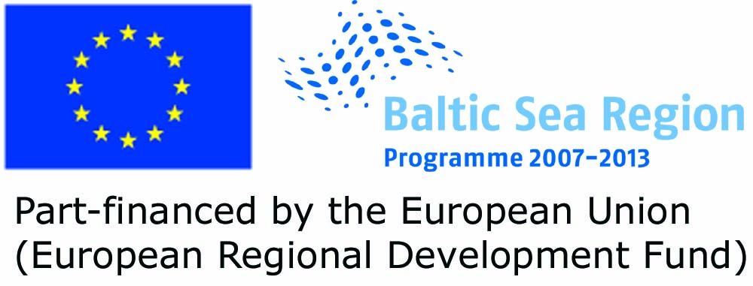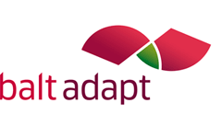

*Personal Invitation to Participate in the Baltic Sea Region Workshop:*

**Climate Change and Tourism – responding to Baltic Sea wide Challenges**

The pan-Baltic tourism sector faces challenges from climate change. These include the need to develop in a sustainable way, which requires adaptation to the consequences changing climate. Many problems and opportunities will be shared by those active in the tourism sector in the region, whereas other will differ.

Involvement of local/regional authorities and sector organizations in the development of the strategy and action plan are crucial.

The workshop is part of the BALTADAPT project ([www.baltadapt.eu](http://www.baltadapt.eu)) which aims at developing a Baltic Sea Region wide adaptation strategy that will form the basis for a region wide action plan. We will offer a unique opportunity to explore specific challenges and opportunities for climate change adaptation on tourism with representatives from tourism associations and administrations all Baltic Sea Riparian Countries.

The workshop will take place lunch-lunch 2-3 May 2012 as a Side-Event of the Baltic Sea Tourism Conference (www.baltic-sea-strategy-tourism.eu) in Warnemünde, Germany, held 3 to 4 May.

We would highly appreciate your participation.

Please give a response to [lotta.andersson@smhi.se](mailto:lotta.andersson@smhi.se) not later than 10th of March regarding your possibility to participate, or if you unfortunately not have the possibility, a recommendation of another participant from your country.

Details with regard to the program and logistics will be forwarded later.

Best Wishes,

Lotta Andersson

Swedish Meteorological and Hydrological Institute (SMHI)

601 76 Norrköping

Sweden

Email: [lotta.andersson@smhi.se](mailto:lotta.andersson@smhi.se)

Phone: +46 11 495 81 44