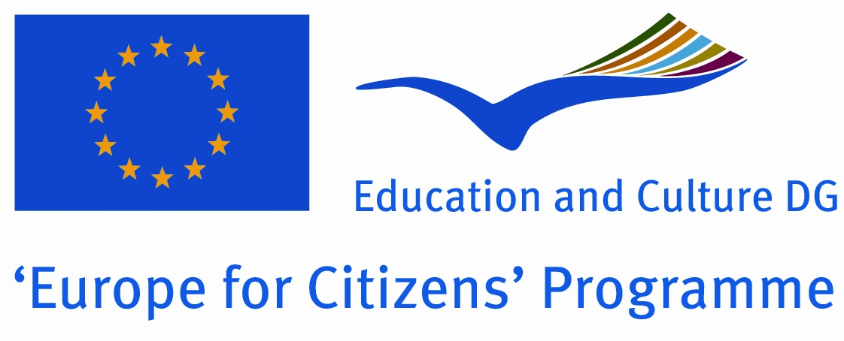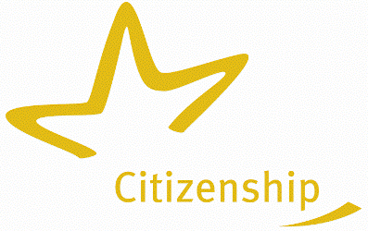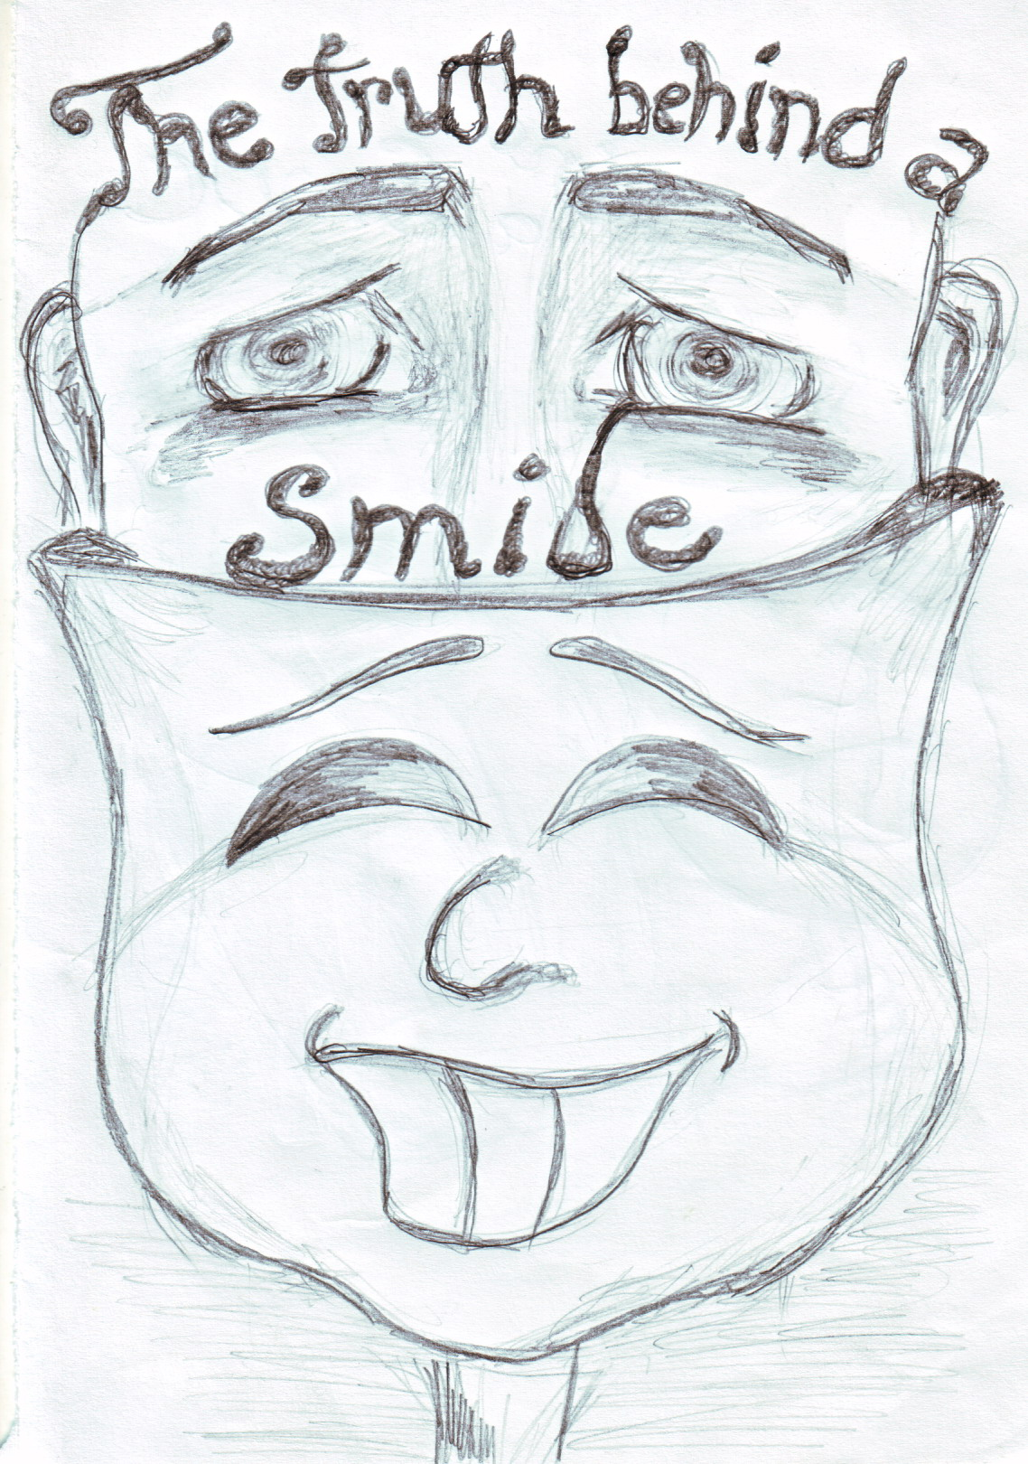

Name of the Town | Năsăud
County | Bistriţa-Năsăud
Region | Transylvania
Country | România
Name of the mayor | Mureşan Dumitru
Surname and Name of the Contact person and Function | Soare  Carmen  Mobile +40749022975 / +40263361027
Address | Unirii Square  Nr 15, Nasaud, judetulBbbBistrita _
Telephone Fax number | +40263361027  +40263361029
E-mail | pon@primarianasaud.ro, carmen_alin@yahoo.com
Website | www.primarianasaud.ro

„The Truth behind a Smile“
Europe for Citizens Programme

The Idea of Project

"The Truth Behind a Smile" is an international project which involve the municipalities, social services and labour market agencies from seven different towns of Europe : Lefkara (Cyprus), Alexandria (Greece),Kavadarci (Macedonia), Mandello del Lario (Italy), Mlawa (Poland) and Nasaud (Romania). The project will have seven events and each event will take place in a different town for six days. Each event will involve 70 different participants( 60 foreigners and 10 locals), so as a total our project will involve about 490 people. The main objective of our project is to fight against unemployment, poverty, school abandon and to promote voluntary spirit within citizens. This project will help disadvantaged people to find a way to earn their living and to have a better life. The participants will visit the poor people’s homes, elderly homes, children homes to bring "a ray of sun" in their lives. There will be several workshops for reducing unemployment and to find a solution for those people who lost their hope in life. The project wants to open some doors and the hearts of decisional factors, to encourage them to help an excluded society. The participants will fight for equal rights and society integration of disadvantage ones. They will support the youngsters who, due to the financial problems, gave up education and now are homeless, the elder people forgotten in nursery houses or the adult people who lost their jobs, or who never had an opportunity to have a job. Another way of integrating disadvantaged people in the society will be to involve them in different ecological volunteer actions as greening areas and using the garbage for making art objects and planting the trees of friendship in the deforested places. Participants will share their experiences, will learn from history and will build a common future together. The intercultural activities foreseen in the project will raise the awareness of participants upon other cultures.

VENUE OF THE PROJECT

The activities of the project will take place in the following towns: Lefkara(Cyprus),Alexandria (Greece), Kavadarci (Macedonia), Setubal,( Portugal), Mandello del Lario (Italy), Mlawa (Poland) and in Nasaud (Romania). The project will contain an event in each town of the municipalities involved, so as a total there will be seven different events in seven different countries all containing actions which will fight against poverty and social exclusion and actions which will promote the voluntary spirit of the participants and of the communities in which they live.

OBJECTIVES OF THE PROJECT

"The Truth Behind a Smile"is an international project which will involve organizations from seven countries of Europe. It is a project which will unite a large number of different people who will work all together for reducing unemployment, will fight against poverty and will promote the volunteering actions in the communities in which they live. The goal of the project will give the citizens the opportunity to interact and to construct a tighter-knit Europe, it will unite them and determine them to cooperate and for certain at the end of the project will become all friends and will enjoy the results of the project. It will strengthen the development of European solidarity as we are bound together and have a common vision and task and also the will to act together through several workshops to change in a good way the poor people's lives. This project will bring a contribution to the development of a common European identity which is a permanent process. Participants will agree on common perceptions of themselves and others, will feel that they belong to the same family with a common value and history and will cross all the differences between them. The participants will accept and respect each other's ideas, will tolerate each other against all the differences between them. The project will promote through the several intercultural evenings a cultural and linguistic diversity, contributing to the intercultural dialogue. All the seven towns involved in the project face the same social problems ( unemployment, poverty, homeless children, pollution) and participants will all unite their forces to fight against them. They are all interested in promoting the volunteering within citizens. There will be several workshops of volunteering ( visit to children houses, elderly houses, planting the trees of friendship, greening areas and using garbage to make art objects) which will promote an active European citizenship and values as tolerance, mutual understanding and solidarity. A great importance will be given to the day of Europe and it will be celebrated together, raising the awareness of the citizens about its meaning. The main goal of our project is to fight for our communities' citizens well being, will promote employment, social cohesion and the sustainable development of the community. The immigrants will have the opportunity to express through one of our workshops their problems. Through the events of the project they will share their experiences and will learn from their history to build a common future together. It will encourage the participants to help other people as many time as possible without waiting any reward and we want to implement in their thinking a few words: "If you want happiness for an hour, take a nap / if you want happiness for a day, go fishing / if you want happiness for a year, inherit a fortune but if you want happiness for a lifetime, help somebody". It is a very old Chinese saying which I think that has a good impact upon citizens. They will be involved in practical voluntary activities during our project as cleaning the banks of the river and using the garbage for making art objects, planting trees in deforested areas and share good practice models with poor people. Through the several video presentations, folk performances from each country, intercultural nights they will benefit of an informal learning concerning other cultures. They will enlarge their cultural horizon.

Number of participants for each event

For each event will participate 10 people from each country, so each event will host 70 people (60 foreigners and 10 local participants) From each country there are invited 3 persons with the age under 30, six persons between 30-65 years old and 1 person over 65 years old. There will be 5 women and 5 men in order to respect the distribution on genders. Within the whole number of participants three persons have to be 3 disadvantaged people.

Event Number | Partner’s  organization | Country | Distribution by age.  >30 30-65 < 65 |  |  | Disadvantaged participants | Woman | Men | Total nr of participants
1 | Lefkara  Municipality | Cyprus | 20 | 40 | 10 | 25 | 35 | 35 | 70
2 | Alexandria Municipality | Greece | 20 | 40 | 10 | 25 | 35 | 35 | 70
3 | Kavadarci Municipality | Macedonia | 20 | 40 | 10 | 25 | 35 | 35 | 70
4 | Mandello del Lario Municipality | Italy | 20 | 40 | 10 | 25 | 35 | 35 | 70
5 | Mlawa Municipality | Poland | 20 | 40 | 10 | 25 | 35 | 35 | 70
6 | Nasaud Municipality | Romania | 20 | 40 | 10 | 25 | 35 | 35 | 70

PERIOD OF EVENTS :

The project will last for two years and it will contain seven events, one in each country involved.

Lefkara (Cyprus) 11-16 of August 2011
Alexandria (Greece) 14-20 of October 2011
Kavadarci (Macedonia) 10-16 of February 2012
Mandello del Lario (It 31Aug -3 of September 2012 ???
Mlawa (Poland) 14-19 of January 2013
Nasaud (Romania) 06-11 of May 2013

PROGRAMME FOR NEW PARTNER

DAY 1

Until 14.00 - Arrival of participants from six foreign countries;
15.00 - Lunch;
16.00 - Speech of the councillor in European Subjects & Speech of the major;
16.30 - Interview with the journalists;
17.00 - Introduction to the schedule of the project. Common work on rules of cooperation in frame of the project; Integration, ex-ante evaluation;
20.00 - Dinner;
21.00 - Power Point presentation of host organisation;

An important result would be finding out many aspects concerning the towns from the foreign countries involved in the project. Through the video presentations the participants will raise the awareness of other cultures, will share experiences and will learn from the history to build a common future. They will make the battle plan for reaching the goal of the project. The activities of this day suppose to familiarise the foreign participants with the new places and peoples. Media promotion

DAY 2

08.00 - Breakfast;
09.00 - Visit to the schools
11.00 - Workshop at the high school with representative teachers and director: “Integration of immigrants in the High School”;
14.00 - Lunch ;
15.30 - Visit of the town
17.00 - Meeting at the special centre for youngsters with problems;
20.00 - Dinner;
21.00 - Intercultural evening (folk dances and music, legends, traditional cuisine);

Participants will integrate in the society of the town will find out the main problem and the causes of social exclusion of youngsters, integration, discrimination and will find the means to fight against it. Participants will have the possibility to know more about the town and people of the town the problem of integration between the youngsters, the problem of integration in the schools and high schools, educational standards and advantages and disadvantages of immigration.

DAY 3

08.00 - Breakfast;
09.00 - Visit to the Agency of Local Development;
11.00 - Visit the Commonwealth of Social Services;
12.00 - Workshop dedicated to enterprises, workers, social problems, integration problems, youngster problems and family problems - following previous visits;
14.00 - Lunch;
17.30 - Visit the old historic part of the town
17.30 - Workshop: “ New technologies for finding a new job";
19.30 - Visit to the elder people asylum;
20.00 - Dinner;
21.00 - Singing evening;

Participants will work directly with the representants of the special centres of the town who deal with unemployed persons, workers, curriculums, orientation, formation and courses, family problems, integration problems and so on. They will make a comparative analyses between their countries and other countries' situation. There will be several questions such as : Is the reality the same in each country? Do all the countries have the same problems? Raising awareness of other cultures. Singing evening.

DAY 4

08.00 - Breakfast;
09.00 - Meeting in the telecentre and interview with immigrant persons coming to the telecentre for a job;
11.00 - Workshop :“New technologies in Information and Communication. How can we use them ?”
12.00 - Visit to the area where the poor people live;
13.00 - “Do we consider the poor people different;
15.00 - Lunch;
16.00 - Visit to the modern part of town;
17.30 - Exposition of small and medium enterprises;
20.00 - Dinner. Video presentation of the previous events;

Participants will work and speak with immigrants in order to have a direct connection with them. They have to know their real problems, in what areas they work in and why did they work in these areas. They will find out the situation directly from the poor people of the town and they will have a general idea about the poors in the town. They will reach conclusion about the differences between their countries and other countries and also about the situation of immigrants in the town

DAY 5

08.00 - Breakfast;
09.00 - Visit to the local enterprises (small and medium);
12.00 - Workshop: “The opportunity of finding job in small or medium enterprises”;
14.00 - Lunch;
15.30 - Workshop: “How to make a new little or medium enterprises”;
18.00 - Workshop: “The possibility of copy some little business in the other countries or reverse”;
20.00 - Dinner;
21.00 - Intercultural evening;

The different workshops and meetings with representatives of medium enterprises will give the participants the opportunity to establish small or medium companies in their own countries based on the information and knowledges they have gathered during the workshop. That companies new companies will create new job opportunities for poor people. These workshops will help to establish contacts between the interested parties.

DAY 6

08.00 - Breakfast
09.00 - Informing and counseling workshop - Sociologists will advice the disadvantaged persons how to find a better job
11.00 - Presentation of the results of the meeting. Discussions about the expected things and the results of the event , planning the next meeting, final evaluation, filling in the participation lists and brainstorming for follows up of the project; Media will be present to promote the results of the event;
14.30 - Lunch;
16.00 - Departure of participants;

We will try to connect individuals who were denied unemployment insurance benefits to the legal counselors that will impact the administration of unemployment insurances; solving this problem seems to be a fundamental objective for unions and associations of the unemployed persons. Final evaluation forms will be filled in, so that the host organization will find out the opinion of participants and the level of organization of the event. New projects ideas will come out as follow-ups.

