



Union of Baltic Cities
Commission on Urban Planning
Project - Alliance of Baltic Cities (ABC)

Renewal of city districts
Reuse of coastal and central residential areas
towards sustainability

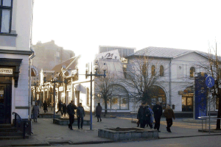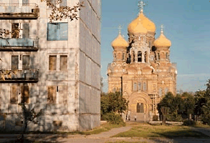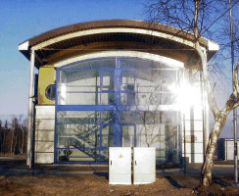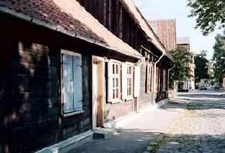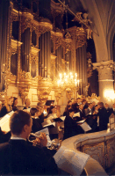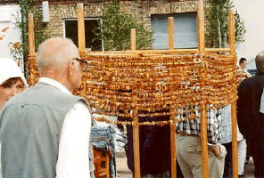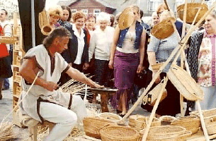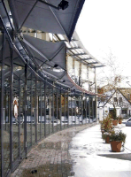

Registration for the third ABC Seminar
in
Liepaja, Latvia
21st-25th of April, 2004

INVITATION

The Commission on Urban planning, the participants in work-package 3, and especially the city of Liepaja, warmly welcomes you to the third seminar of the ABC-project to be held in
Liepaja, Latvia, from 21st to 25th of April 2004.

The program is still somewhat preliminary and can be due to some minor changes. You will receive a final program for the conference at the end of March.

Due to organisational difficulties related to different parts of our project there was a delay in announcement of our seminar. We are sorry for this delay, but now we are sure the seminar will happen. Thus we have to proceed rather quickly.
Therefore, please, send in your registration form as early as you can.
For practical reasons we would be grateful if we could receive the registration form before 19th of March.

Welcome to Liepaja- the city where wind gets born!

Ugis Kaugurs XXXX XXXX
Chief architect
From behalf of
The City of Liepaja. Anyone from
Gunilla Kronvall
Architect
From behalf of
The city of Malmö, lead part of WP3

WP3 working group:

 | 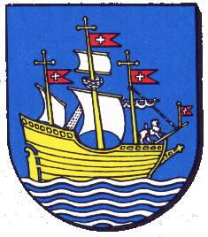 |  | 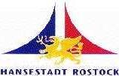 | 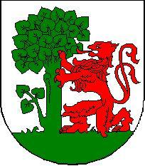
Malmö | Nykøbing F | Pärnu | Rostock | Liepāja

PRACTICAL INFORMATION

ABC Liepaja Seminar secretariat

Ugis Kaugurs
Liepaja Building board

Rozu st. 6, Liepaja, LV 3401
Tel. +371 3404725
Fax +371 3423391
e-mail: ugis@dome.liepajalv

Natalja Vecvagare
Liepaja City Council
Foreign Relations and Protocol Department
Rozu st. 6, Liepaja, LV 3401
Tel. + 371 3404790
Fax: +371 3404777
e-mail: natalja@dome.liepaja.lv

General information

Weather
The weather in Latvia and Liepaja in the end of April usually is rather nice and similar to what you can experience in other coastal towns of Western Baltic’s. Yet remember- weather can still change rapidly, so better be prepared for unpleasant surprises, too.

Borders
At the time of our seminar Latvia will still be a NON-member of EU. No visas needed for representatives from any of our participant countries (excepting Russia), but the rest of procedure will be the same as usual. The sunny side remains the tax-free shopping.

Currency
Our national currency is 1 Lats [LVL]= 100 santimi ~1,49 € [EUR] / 1 €~ 0,67 Ls
Credit cards are accepted in most places and cash dispensers are widely available.
When going out, tips at the rate of some 5-10% are welcomed at bars and restaurants (if not indicated as included on the bill).

More information about Liepaja you can find on internet
www.liepaja.lv
[in English www.liepaja.lv/en/liepaja/ ]

Participation
According to the agreement in the ABC project, the participating cities are requested to send one or two representatives to the seminar. Representatives from cities in EU-countries will get travel, hotel costs and certain meals covered by the ABC project.

Please note:
- Only APEX Flight Tickets will be refunded by the ABC project.
- Expenditures will not be refunded for more participants than agreed in the ABC project.
- The project pays for the hired bus Riga-Liepaja-Riga. The project will NOT cover any other means for transport Riga-Liepaja-Riga (bus/taxi/car).
- As it was stated and pre-warned already in Vaasa, the project will NOT pay for any travels - Riga to/from your resident city for the participants from the Candidate Countries.
- The project will however pay for hotel & accommodation for ONE participant from each of the cities of Kärdla, Narva, Viljandi, Pärnu, Tartu, Jekabpils and Jurmala. (Riga, Gdansk, Gdynia and Szczecin pay for themselves).
- It might be necessary for the participants to cover for one of the meals themselves.

Transport
Flight:
- Arrival at Riga Airport on Wednesday, April 21.
[Only APEX Flight Tickets will be refunded by the ABC project.]
A taxi to centre would be some 5-7 Ls. Only few taxis accept credit cards- so you have to check it first. Bus connection to centre is available round at every 20-30 min.
First night stay and some dinner will be arranged in Riga. Stay at hotel “Radi and Draugi” (Mārstaļu 1/3, Rīga phone.+3717820200 www.draugi.lv)
A hired buss will be arranged to take all of us to Liepaja on Thursday morning at 8:30 from hotel.

- Alternately you will have to take a bus (~3,5 hour/ 210km) to Liepaja from Central Busstation Riga
Time table for bus: http://www.118.lv/118/new118/auto_sar.php3
- Car rental is another option. More detailed info you can get at Airport or on internet:
www.hertz.lv www.europcar.lv www.avis.lv

By car:
For those preferring a car ride instead, please, take A9 (when coming via Riga) or A11 (when coming via Klaipeda/Palanga, Lithuania).

Stay
Rooms will be booked for all the participants who will send in the registration forms.
You will stay in hotel LĪVA [***]located in the very heart of Liepaja- the Rozu [Rose] square.
Līva [akin to Liiv -the sand] once was the name of a small river and a village first mentioned in chronicles 750 years ago. Later it gave the name to the town and city (the Rights of City were granted by the Duke of Kurland in 1625). [Liiv<Līva<Lībava<Libau<Liepāja]
Hotel info: www.liva.lv/
(Sorry- no spas this time☺)

Seminar meetings
General meetings will be held in conference rooms at the same hotel LIVA.
The group work will be arranged in other locations- closer to the sites under discussion.

Work Groups
Please, inform us in the registration form, in which of the following groups you prefer to participate.
It is preferable, for sharing your competence and experiences as good as possible, if participants from the same city take part in different workshops.
Also we will try to send later some specific additional information on the scope of group work to the interested participants.

Group 1:
Revitalisation of mass-housing blocks from 80-ties in Ezerkrasts [Lakeside]
- social scenarios and adequate housing schemes
- housing and nature [landscape/ waterscape]
- improvement of quality to housing area

A wasted territory between two housing districts provides unique opportunity to develop new housing area with better solutions, to compensate/ improve flaws of former mass-construction practice.

Group 2:
Revitalisation of historical blocks at Vecā Ostmala [Old-Portside]
- future for City centre
- new use of old building structures
- role of the commerce and infrastructure in revitalisation

An old and once romantic area between the very centre and Old Portside was cut off the waterfront and lost any purport or meaning. Will we be able to find the way how to get it back to life again, when the access to the Portside is provided?

Group 3:
Revitalisation of former military city Karosta [Navy port]
- new use of old building structures
- social/ economical scenarios and adequate development schemes
- infrastructure consequences

A huge area, actually- a completely self-contained town itself has been created and existed, depending solely on military base. 10 years after removal of troops we are still on our way to adopt it as a inbred part of the city.

[PRELIMINARY] AGENDA FOR ABC LIEPAJA SEMINAR

Wednesday 21. April 2004

Arrivals in Riga
Stay at hotel “Radi un draugi”
Mārstaļu 1/3, Rīga
t.7820200
www.draugi.lv
19.00 | informal “get together evening”.  Restaurant ???? [to be announced later].  Assemble in hotel lobby 20 min ahead for a joint walk or transport.

Thursday 22. April 2004
08.30. | A bus trip to Liepaja
 | Welcome and a some introduction to Liepaja [for those awake]
11.30-12.00 | Arrival in Liepaja, accommodation at Hotel LIVA
12.00 | Lunch  in the hotel’s restaurant UPE [The river]  Lars Brattberg will give us a brief information  about the EU/Phare-situation etc.
13.00 | Plenum. Opening remarks  Conference room KALNS in hotel LIVA, 4th floor
 | Welcome and a short introduction to Liepaja
 | Practical information on the Liepaja Seminar
13.45 | Renewal of city districts- emergency or challenge?  Speaker to be announced
14.30 | Coffee break
15.00 | Guided tour by bus in Liepaja
19.00 | Dinner  Restaurant Vecais Kapteinis [Old Captain]

Friday 23. April 2004
09.00 | Introduction to the role of Liepaja in the region and the urban development in Liepaja  The Mayor Mr.Uldis Sesks, Liepaja  The Head of Development departament Mr. Gunars Ansins, Liepaja  Conference room KALNS in hotel LIVA, 4th floor
Formation into workshop groups.
Introductions to the topics for the different workshop groups.
10.30 | Coffee break
11.00 | Excursions to the sites for groups 1-3
12.00 | Group work
13.00 | Lunch in working groups
14.00 | Group work
19.00 | Banquet. Hosted by the City of Liepaja  Restaurant Oskars vai Nīcava

Saturday 24. April 2004
09.00 | Group work. Preparing report and presentation
12.30 | Lunch  Restaurant ???
13.30 | Plenum  Presentations and Proposals from work Groups 1-3  Conference room KALNS in hotel LIVA, 4th floor
15.00 | Coffee break
15.30 | Good examples on seminar topics from 3-4 elected cities  Introduction and discussions
17.30 | Excursion in the Liepaja region,  “Kurland country-style” dinner in a small chateau Garikas

Sunday 25. April 2004
09.00 | Conclusions and closing remarks  Looking ahead to the next ABC seminars
 | Coffee break
11.00 | A bus trip back to Riga  The departure time can be rearranged slightly depending on the schedule of the majority of your flights.
~14.00 | Arrival at Airport Riga  Bus can also be arranged to go to the Airport first and then to the Centre of Riga. Those, having late flights can spend some extra hours in Old Riga then..  Taxi ride from centre back to the Airport takes ~30 min.

REGISTRATION FORM . ABC LIEPAJA SEMINAR

(one person per form only)
First Name: | ❑ Mr  Mrs  Ms  (please indicate)
Family Name:
Position:
Official postal address:
City:
Country:
Your E-mail:
Tel. / Fax

Full seminar programme participation (4 nights): |  | ❑ Yes  No  (please indicate) | Excursion 24/04/04: | ❑ Yes  No  (please indicate)
Arrival date: |  | ❑ Riga   Liepaja | Approx. time: | ❑ Riga   Liepaja
Departure date: |  |  | Approx. time:
Transport  (indicate) |  | ❑ Flight (to Riga)  and arranged bus from Riga on 22/04/04 | ❑ Regular Bus transfer | ❑ Car
Other means: | ❑

I want to participate in (please indicate)
Workshop 1 | Workshop 2 | Workshop 3 | plus presentation
❑ | ❑ | ❑ | ❑

❑ I am interested in presenting the following project, as a good example on a seminar theme:

________________________________________________________________________________________________________________________________________________________________________
____________________________________________________________________________________

Date / Signature______________________________________________________________________

This Registration Form must reach Liepaja before March 19th , 2004.
Please, send it to Natalja Vecvagare, fax +371 3404777 AND e-mail: ugis@dome.liepaja.lv

