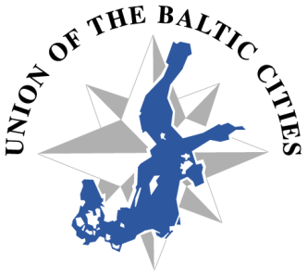
70th Meeting of the Executive Board
Turku, 2 June 2014

PRACTICAL INFORMATION

MEETING VENUE
Radisson Blu Marina Palace Hotel
Linnankatu 32, Turku
Meeting room “Dining room”
http://www.radissonblu.com/hotel-turku

ACCOMMODATION
Radisson Blu Marina Palace Hotel
Tel +358 20 1234 700
e-mail: reservations.finland@radissonblu.com

Price of single room (incl breakfast) /night: 121 EUR €
Double room (incl breakfast)/night: 131 EUR €
There are also other room types available, more info at:
http://www.turku.fi/public/default.aspx?nodeid=19609&culture=en-US&contentlan=2

Please book the hotel latest by 30 April 2014. On 1 May 2014 the hotel rooms will be released for open sales.
Please use reservation code: TBSD

MAP
https://maps.google.pl/maps/ms?msid=209290018094901561692.0004f6c39a64dcb634c95&msa=0&ll=60.452731,22.260361&spn=0.017354,0.038581

TRANSPORTATION
Public bus number 1 from the airport makes a stop in front of the Radisson Blu Marina Palace Hotel. One way ticket is 3 EUR. A taxi from the airport to the hotel costs 15-17 EUR (daytime).

EUSBSR Annual Forum and BDF Summit
There is bus transportation provided on behalf of the TBSD to the get-together party (Caribia) from the hotel on Monday and to the Networking party (Forum Marinum Museum) from Logomo on Tuesday. And also back to the hotel.

The timetables can be found here: http://www.bsr2014.eu/social-events/

No bus transportation is provided to Logomo. The participants of the EUSBSR Annual Forum and BDF Summit are encouraged to take the public transportation or walk to Logomo. There will be guided walks arranged from the hotels to Logomo in the mornings.

The distance from Marina Palace hotel to Logomo is 1,7 km. (on the map https://maps.google.fi/maps/ms?msa=0&msid=216973691589927608168.00043b92de0678db8a8a2&dg=feature )

CONTACT PERSON
With any practical question please contact:
Ms Jaana Kerttula
Centrum Balticum
Tel. +358 40 509 7139
Mob. +358 40 509 7139
e-mail: jaana.kerttula@centrumbalticum.org

