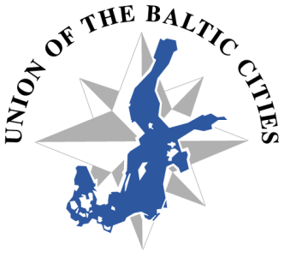

Union of the Baltic Cities
70th Meeting of the Executive Board
Turku, Finland, 2-3 June 2014

Registration form

Name: Mr/Mrs/Ms

Position:

City:

Address:

Phone:

GSM:

e-mail:

Arrival date time place

Departure date time place

Date and name

Please email this registration form to the UBC Secretariat in Gdańsk and to the City of Turku by 30 April 2014.
E-mail: info@ubc.net (UBC Secretariat) and E-mail: jaana.kerttula@centrumbalticum.org (City of Turku)

This is not the hotel booking form, for hotel booking please contact directly reservations.finland@radissonblu.com by 30 April 2014 at the latest.

Registration to the 5th Annual Forum of the EU Strategy for BSR and the Baltic Development Forum Summit at: http://www.bsr2014.eu/registration/

