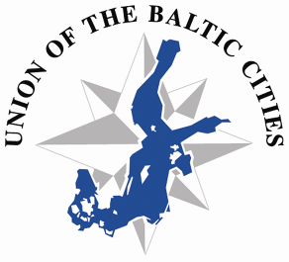

69th Meeting of the Executive Board
Tampere, 17-19 March 2014

Auditorium of Museum Centre Vapriikki
Address: Alaverstaanraitti 5 (Tampella area)
www.tampere.fi/english/vapriikki.html

PROGRAMME

MONDAY, 17 March 2014
Arrival of the participants
19.30 Get-together dinner at Old City Hall, Keskustori 10, central market square

TUESDAY, 18 March 2014
9.30-12.00 Meeting of the Executive Board open session
10.40 Coffee & tea
12.00-12.20 Press conference
12.30-14.00 Lunch at Restaurant Valssi, Museum Centre Vapriikki, Alaverstaanraitti 5
14.00-16.30 Continuation of the Board meeting closed session
15.10 Coffee & tea
16.30 Study visit to Demola centre www.tampere.demola.fi
19.30 Dinner at restaurant Astor, Aleksis Kiven katu 26

WEDNESDAY, 19 March 2014
9.30-15.30 Snowmobile or quad adventure, all equipment will be provided
Bus departure from Tammer hotel at 9.30
Departure

