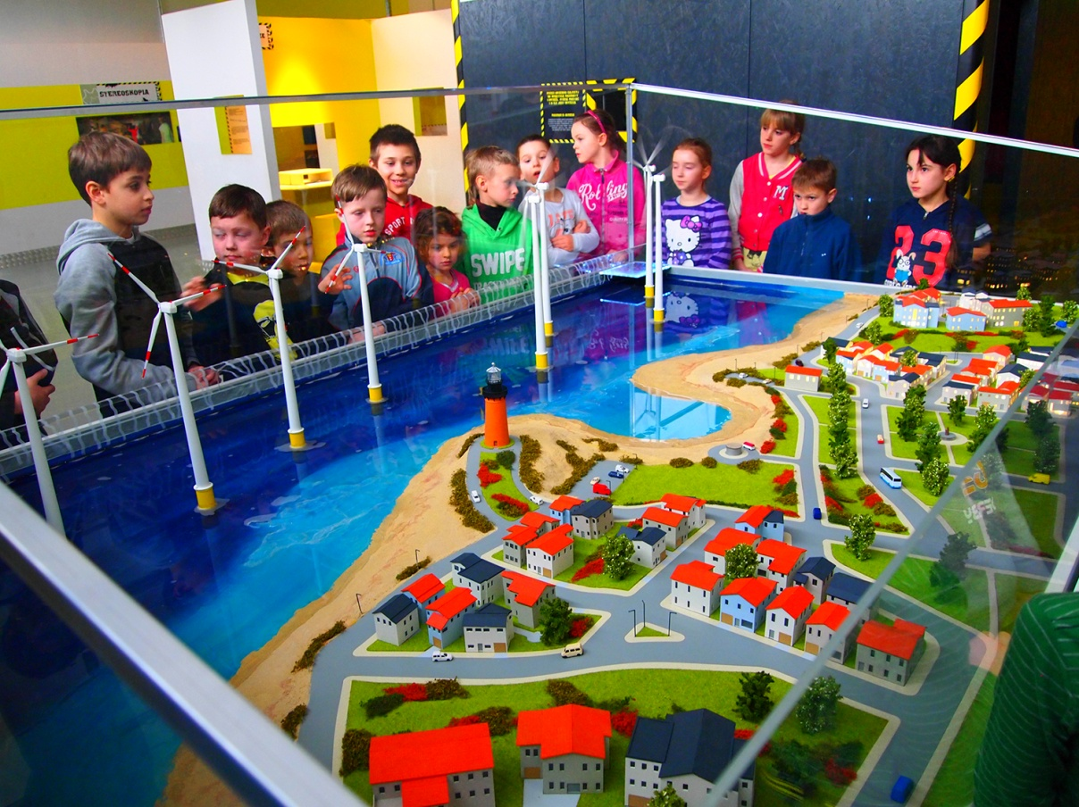

In keeping with the slogan of the conference “From words into action - Combating youth unemployment and marginalization”, the Joint Technical Secretariats of the South Baltic and Central Baltic cross-border co-operation programmes have designed a workshop to showcase commendable cross-border initiatives in the field of youth welfare. The session took place on 3rd October, and was attended by more than 60 representatives of Baltic cities and their youth organisations.

Insights into the programmes and their future prospects as well as into the youth welfare efforts made by their beneficiaries were provided by Thorsten Kohlisch, head of the South Baltic secretariat and Bo Storrank, acting head of the Central Baltic secretariat. The principle of cross-border co-operation obtained strong political endorsement from high-level representatives of cities involved in youth-related cross-border projects during a subsequent panel discussion. In particular, Mayor Roland Methling of Rostock, Councillor Maja Wagner of Gdynia, Deputy Mayor Taavi Aas of Tallinn, Mayor Mihkel Kübar of Jõgeva and Deputy Mayor Birgitta Ståhl Öckinger of Linköping expressed their belief and confidence in the values of cross-border co-operation. Moderated by Ilona Evelyn Rannala, Head of the Youth Department of Tallinn's City Government, the panel session has been following two discussion threads: “The cross-border experience: enhancing youth welfare policies through co-operation across borders” and “Catch the Baltic winds in your sails: generating the feeling of belonging and taking care”. Bringing the idea of INTERREG into practice, the panel discussion thus turned into an exchange on good practices between the participating cities, allowing the panellists to share solutions for better youth involvement in local policy-making processes.

In addition, Christian Weinberger, senior adviser on SMEs & Entrepreneurship at DG Enterprise and Industry of the European Commission addressed the aspects of youth entrepreneurship, young qualified staff as a resource for SME growth as well as the role of cross-border co-operation in SME and entrepreneurship policies.

The main goal of the workshop was to showcase benefits, and encourage Baltic cities to follow in the footsteps of their counterparts who already advocate the idea of cross-border co-operation.

Furthermore, both programme representatives took the opportunity to update the audience on their preparatory works for the programming period 2014-2020. While the Member States and the European Commission expressed their support for the continuation of both programmes, the negotiations on their priorities, objectives and management are still ongoing. As presented by Bo Storrank, the future programme for the Central Baltic region will focus on the thematic priorities of SME development, environmental protection, resource-efficiency, transport as well as education and lifelong learning, accompanied by the horizontal themes of ICT and low-carbon economy. In the South Baltic area, the fields of business innovation and internationalisation, the protection of cultural and natural heritage, green technologies, transport, labour mobility and cooperation between institutions and citizens have been identified by the Member States and Euroregions as potential priorities for future cooperation, to be agreed and decided in the coming months. As a result of the workshop and the subsequent plenary session, both programme representatives also took one message from the UBC community back home: When discussing the next generation of cross-border projects between cities and municipalities across the shores of the Baltic Sea, not only large-scale projects shall be considered. Indeed, very often projects with smaller budgets and partnerships can make a difference, as they allow newcomers and local actors to benefit from INTERREG and thus may prepare the ground for more ambitious cooperation initiatives in the future.

*Crossing borders for youth welfare*

*Summary of Workshop 4*

XII General Conference of the Union of Baltic Cities

3rd October 2013, Mariehamn – Åland

**Workshop 4: 10:00 – 12:30**

*W.4 Regional INTERREG IV Programmes for the Baltic Sea Region*