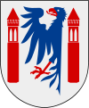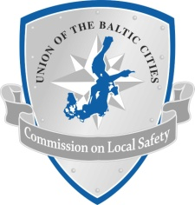
PRACTICAL INFORMATION
16-18 October 2013 in Karlstad, Sweden
Date: October 16-18, 2013. Participants are expected to arrive on October 16th, and are expected to departure on October 18th .
Recommended hotel:
There are several hotels in Karlstad city, and we recommend hotel Scandic Winn, which is located in the city centre.
To book a room, please contact Scandic Winn via telephone or email. When you book the room, make sure you use the reservation code: KAR 171013, to ensure you’ll get the discount. The last day to book a room is on 30th of September.
Ph.: +46 54 776 47 13
Email: mairon.fjellman@scandichotels.com
Price:
Scandic Winn provides a discount for the hotel rooms, and the price is about 80 euros incl. VAT/night and person (890 SEK).
More information
For more information about the hotel, please visit: http://www.scandichotels.com/Hotels/Sweden/Karlstad/Scandic-Winn/
Transportation from/to the airport:
Karlstad airport is located in the outskirts of Karlstad, about 15 minutes from the city centre. We will arrange transportation from and to Karlstad airport.
If you arrive by train/bus we will arrange transportation from the railway/bus station in Karlstad.
If you choose to fly, or go by ferry to Stockholm, we recommend you to opt for the train to Karlstad, or with a connecting flight to Karlstad airport.
Registration & Contact
To participate at the conference, you are expected to send your registration form to Mr. Robin Olsson. Your registration has to be completed at the latest on September 30th. Please send the document to:
robin.olsson@karlstad.se.
Ph.: +46 54 540 28 69

